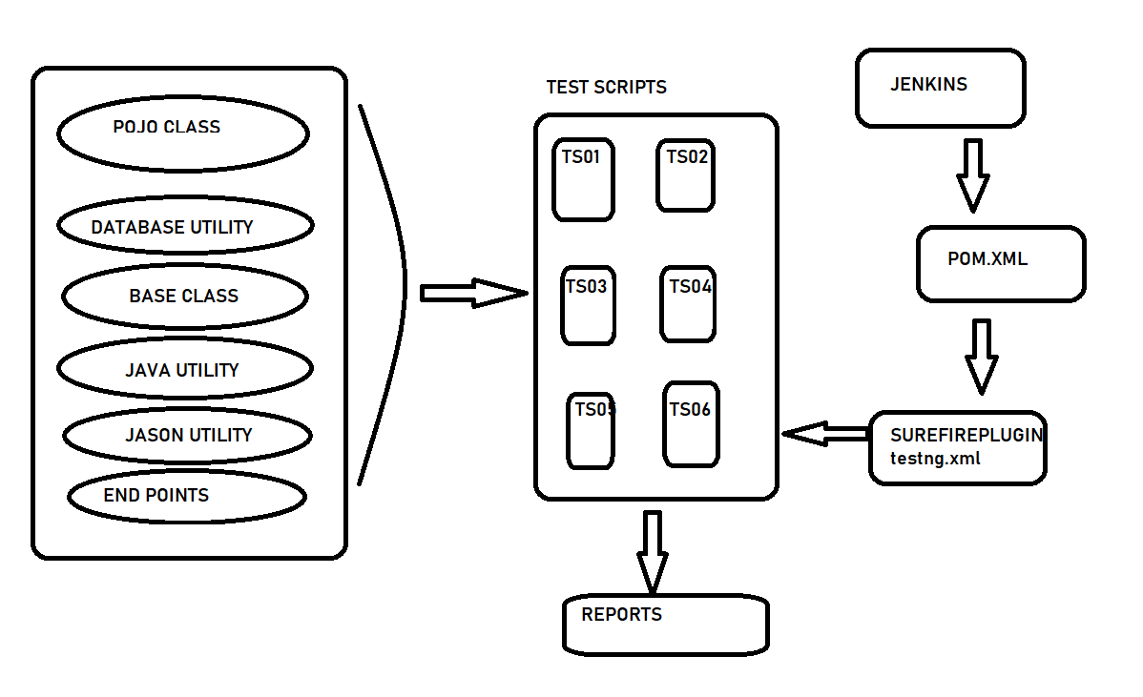

Restassured Framework is a hybrid framework . It is used for Testing and Validating Rest services. It also enhances readability and clean coding to enable seamless testing work flows. Fetching data is easy regardless of the complexity of the JSON structures. The components of the framework are :

1)POJO CLASS

2)DATABASE UTILITY

3) BASE CLASS

4) JAVAUTILITY

5)JASON UTILITY

6)ENDPOINTS

7)TEST SCRIPTS

8) MAVEN

9) REPORTS

10)JENKINS

1. POJO CLASS - POJO classes are extensively used for creating JSON and XML payloads for API. It is a Java design pattern which helps to handle complex request and also achieve Serialization and Deserialisation.
2. BASE CLASS – It consists of testng configuration methods for connecting to database @BeforeSuite – Establish connection with database before the execution of the test script.

@After suite – To terminate the databse connection after test script execution.

1. DATABASE UTILITY – It consists of all the methods provided by JDBC to connect to Database to perform CRUD operation duing the Test script execution.
2. JAVA UTILITY – It consist of Java specific methods to generate random numbers to be appended with the test data to avoid duplicates. And also fetch the System Date.
3. JASON UTILITY – it is used to return Json response data based on Jason path, which is required for complex response validation, fetch individual data from the response and also for achieve request chaining.
4. END POINTS – We store all the endpoints of different API in this class . And it is an interface in the framework as the endpoints remain constant.
5. TEST SCRIPTS – Consists of TestNg test scripts. Test scripts extends to generic library classes to inherit the properties.
6. REPORTS - TestNG comes with certain predefined listeners as part of the library. These listeners are by default added to any test execution and generate different HTML and XML reports for any test execution. The report is generated by default under the folder named **testoutput.xml**
7. MAVEN – Maven is a project build or project management tool. It is used to check the compilation issues between framework components whenever multiple test engineer integrates their files into the same framework.
8. JENKINS – We provide pom.xml path in Jenkins, which triggers the surefirePlugin in the pom.xml file, which will inturn setoff the testing.xml file and it initiates TestScript execution.